Content:

1. Background (explain the problem of the business)

User Story: Want to make a Take-away menu system

Want to Insert the data about menu with different attribute, record in the system

Want to have a history record to record his old visited menu record

Select difference take-away menu by the places or district in Hong Kong

1. System Function

Register Function (email and password)

Login Function (Email and password)

Insert Function (Should Login, must provide Name , at least 1 picture , district , food type and category()

(may provide tel, other photo (limit is 5) start time, end time,address and description)

View History Function(Should login,In profile page)

Search Function ( By different district, popular click rate, food type, take-away type)

View Menu Detail Function (Display all detail for the menu)

1. Project Management

3.1 Agile Processer

3.1.1 Methodology used : Scrum Methodology

3.1.2 Role:我: Scrum Master

你: Developer

Workflow notes 有 (04 Agile Development 19頁開始) (都係吹水)

3.1.3 吹水

3.2 Team Dynamic

3.2.1 01 Professional Development 第19~25頁

3.2.2 3.2.3 避免出現 01 Professional Development 第27頁開始果堆

夾口供 (下面 如需要)

3.2.2 先強調2人組 ~

# 點make decision ?( Collaborative )(有問題立即表示 決定的決策都要雙方確定沒問題) 要有共識(Consensus)

Example ( 如之前 Scrum Master 話要整埋 坐標位置 用家可以知道附近有乜餐店(by user current location) 店資料要入左係DATABSE到) -> 經過討論後決定不做這功能 原因是 涉及google api code,困難。

3.2.3

我地係用face-to-face communicate with whiteboard

因為咁樣可以清晰 仲有乜功能未做 邊度未做好 邊度已完成 更加容易掌握同知道個進度

同有問題 知道邊part有問題 “more effective”

3.2.4 吹水

4.1

DataBaseDesign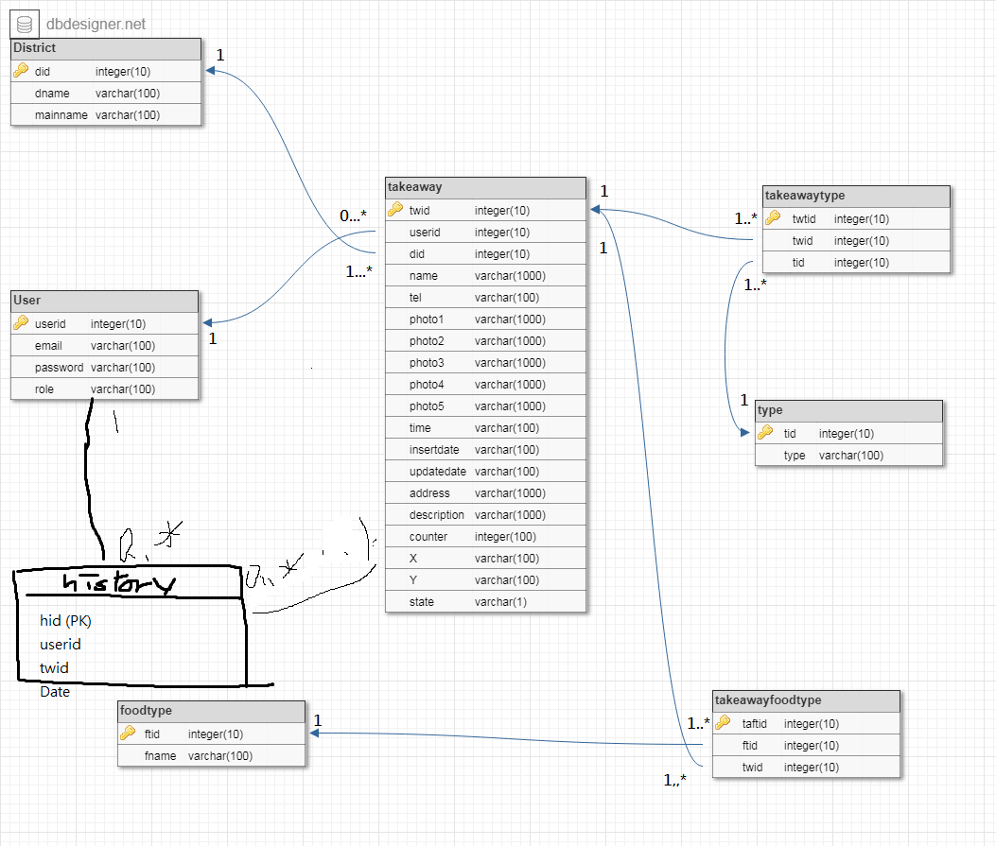

Design Pattern

MVC Model Design pattern

View part (html + css + javascript + less php code)

Controller part ( php code for process the request and throw the data to the view)

Model part( php code throw the data which controller call different model ( access the database)

4.2 用Git (06 Version Control pdf) 吹水

4.3用左(Linting 同 Uniting testing) (跟返07 Automated Test pdf )吹

4.4 冇用到